**ASSIGNMENT-II**

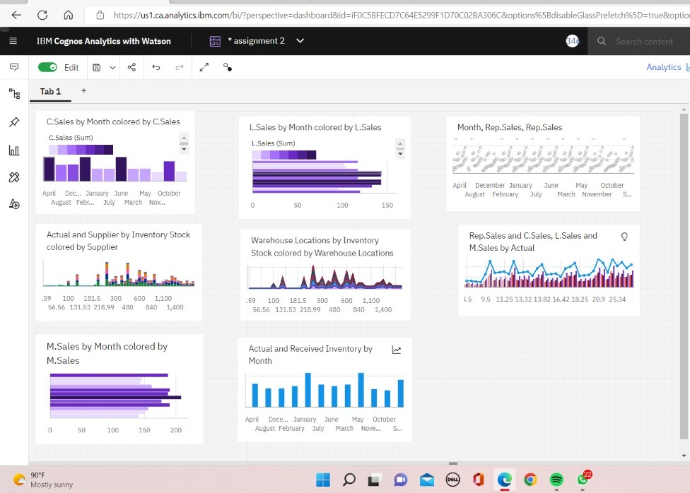

**LINK:**

<https://us3.ca.analytics.ibm.com/bi/?perspective=dashboard&pathRef=.my_folders%2FAssignment-2&action=view&mode=dashboard&subView=model00000183749032cf_00000000>